**1st Year Book Recommendations**

[**The Boy in the Striped Pyjamas**](http://www.booktrust.org.uk/books/view/25439) **by John Boyne**

Berlin, 1942 : When Bruno returns home from school one day, he discovers that his belongings are being packed in crates. His father has received a promotion and the family must move to a new house far, far away. A tall fence stretches as far as the eye can see and cuts him off from the strange people in the distance. But Bruno longs to be an explorer and decides that there must be more to this desolate new place than meets the eye. While exploring his new environment, he meets another boy whose life and circumstances are very different from his own, and their meeting results in a friendship that has devastating consequences.

[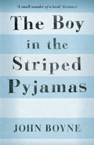](http://www.booktrust.org.uk/books/view/25439)

[**The Hunger Games**](http://www.booktrust.org.uk/books/view/29230) **Trilogy by Suzanne Collins**

Welcome to Panem: its Capitol repressively rules twelve satellite Districts, enslaving the populations as workers and controlling them through hunger. When 16-year-old Katniss's young sister, Prim, is selected as District 12's female representative in the annual Reaping which sees people fight to the death, Katniss volunteers to take her place. She and her male counterpart Peeta, are pitted against bigger, stronger representatives, some of whom have trained for this their whole lives. , she sees it as a death sentence. But Katniss has been close to death before. For her, survival is second nature.

[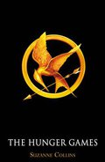](http://www.booktrust.org.uk/books/view/29230)

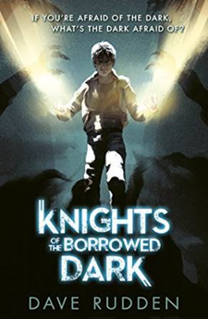

**Knights of the Borrowed Dark by Dave Rudden**

Denizen Hardwick is an orphan, and his life is, well, normal. Orphans are just kids without parents. At least that’s what Denizen thought. On a particularly dark night, the gates of Crosscaper Orphanage open to a car that almost growls with power. The car and the man in it retrieve Denizen with the promise of introducing him to a long-lost aunt. But on the ride into the city, they are attacked. Denizen soon learns that monsters can grow out of the shadows. And there is an ancient order of knights who keep them at bay. Denizen has a unique connection to these knights, but everything they tell him feels like a half-truth. If Denizen joins the order, is he fulfilling his destiny, or turning his back on everything his family did to keep him alive?

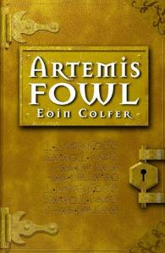

**Artemis Fowl by Eoin Colfer**

Artemis Fowl is a millionaire criminal mastermind. And he’s only twelve years old. The first book in a hugely popular series sees Artemis bite off more than he can chew when his cunning plot to steal all the fairy gold goes horribly wrong. A smart, well plotted and funny book that combines folklore and technological high jinks into a thrilling adventure.

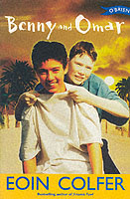

**Benny and Omar by Eoin Colfer**

Benny has to move from Ireland to Tunisia in North Africa because of his father’s work. He hates it there until he makes friends with a local boy, Omar, who only speaks English in TV catchphrases. Lots of adventures and great fun follow as the friendship grows between the two boys.

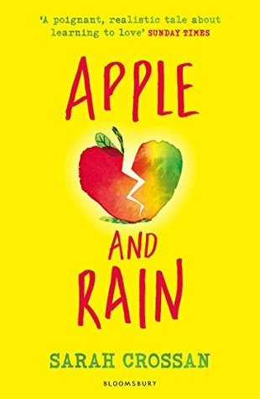

**Apple and Rain by Sarah Crossan**

When Apple's mother returns after eleven years of absence, Apple feels whole again. She will have an answer to her burning question – why did you go? And she will have someone who understands what it means to be a teenager – unlike Nana. But just like the stormy Christmas Eve when she left, her mother's homecoming is bittersweet, and Apple wonders who is really looking after whom. It's only when Apple meets someone more lost than she is, that she begins to see things as they really are.

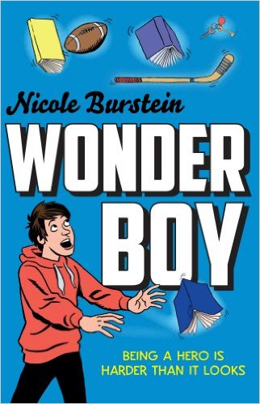

**Wonderboy by Nicole Burstein**

Joseph ‘Wilco’ Wilkes is one of life’s loser’s – he’s picked on, pushed around, and bullied by the rugby boys at the posh private school he attends on a scholarship. But his life is about to change: Wilco learns he can move things with his mind. Will this be his chance to play the hero, get the girl and finally stand up for himself? Or are things just going to come crashing down around his head? Becoming a proper hero will be quite the leap of faith...

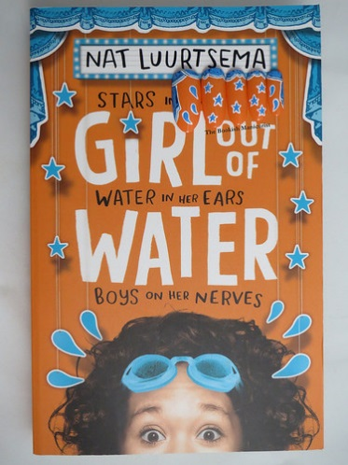

**Girl out of Water by Nat Kuurtsema**

Lou Brown's life is going down the pan. Best friend Hannah sailed through the Olympic time trials and is off to her fancy-pants new swim training school, while Lou's own failure to qualify leaves her without a hobby - or a friend. As Lou tries to navigate her post-swim world, a chance encounter with three boys with stars in their eyes takes her life in a surprising new direction. One that leads to a crazy world of underwater somersaults, talent show auditions, mean girls and one great big load of awkward boy chat. This gem will make you laugh and is perfect for fans of Louise Rennison!

**And Actually… by Denise Deegan**

This is the third volume in the Butterfly Novels series, about 3 friends, Alex, Sarah and Rachel who attend an elite Dublin school for children of the rich and famous. This one focuses on the ‘together’ Rachel, the problem-solver of the group – who turns out to have a problem of her own. Haunted by bullying she experienced in primary school, Rachel is forced to confront her past when she finds herself working with one of her tormentors on the set of an Irish medical drama. Combines serious issues with the glamorous world of television.

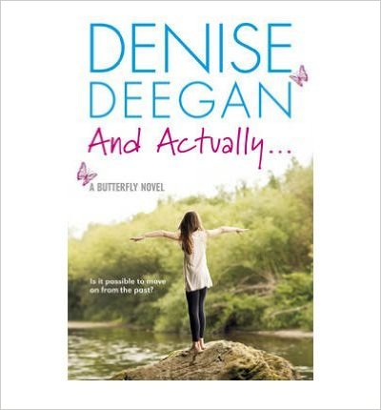

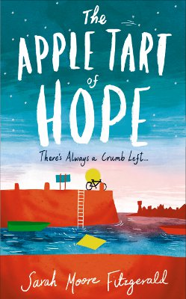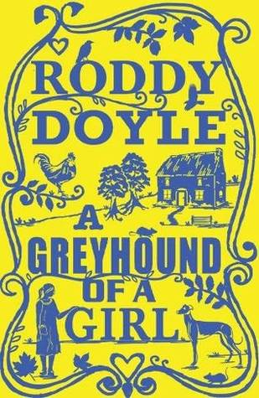

**A Greyhound of a girl by Roddy Doyle**

Mary’s beloved Granny is dying, but is finding it hard to let go. When the ghost of her own mother turns up to help her pass over, four generations of women go on a road trip. Dealing with issues of loss and bereavement and bonds between mothers and daughters with his trademark wit and sharp dialogue this is a sensitive and humorous read.

**Apple Tart of Hope by Sarah Moore Fitzgerald**

The best baker in the world, Oscar Dunleavy, is missing. Everyone presumes he is dead but no one seems too surprised. Only Meg, his best friend, and his little brother Stevie are shocked. Surrounded by grief and confusion, Meg and Stevie are determined to find out what happened to Oscar, and together they learn about loyalty and friendship and the power of never giving up hope.

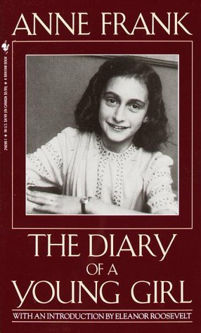

**The Diary of a Young Girl by Anne Frank**

In the summer of 1942, fleeing the horrors of the Nazi occupation, Anne Frank and her family were forced into hiding in the back of an Amsterdam warehouse. Aged thirteen when she went into the secret annexe, Anne kept a diary in which she confided her innermost thoughts and feelings. An intimate record of tension and struggle, adolescence and confinement, anger and heartbreak, this is the definitive edition of the diary of Anne Frank.

**Across the Divide by Brian Gallagher**

Historical fiction by a Dublin author set around the strike and lockout of 1913 and the friendship between a wealthy girl and a working class boy. Excellent, informative read with plenty of adventure ensuring kids don’t feel too bogged down in history.

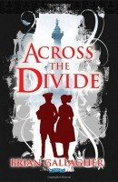

**Coraline by Niall Gaimon**

A surreal read packed with tension and fantastic imagery this book is one of our most popular junior book club choices. The main character Coraline gets trapped in a parallel world on the other side of her sitting-room wall. Coraline shows great thought and bravery to return to her real life at the end of the story.

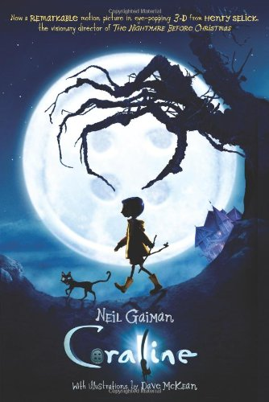

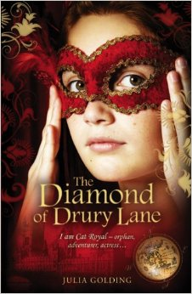

**The Diamond of Drury Lane by Julia Golding**

Set in 1790's Covent Garden, this book whisks you back to a bygone era and into the magic of the theatre. Cat Royal's colourful slang and confident I'll-tell-you how-it-really-is attitude makes the story sparkle off the page. She is an orphan who lives at the back of the Theatre Royal in Drury Lane, and mingles with the high and low of society. Packed with authentic detail, it’s also a gripping mystery.

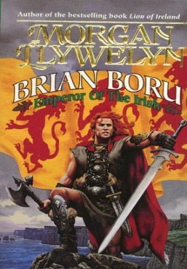

**Brian Boru by Morgan Llywelyn**

An enthralling account of the life of Brian Boru, who grew to become High King of Ireland before dying in the Battle of Clontarf in 1014.

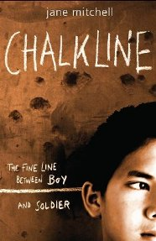

**Chalkline by Jane Mitchell**

Rafiq is only nine but he’s tall for his age and when Kashmiri freedom fighters come to his village looking for new recruits he is forced to go with them. This hard hitting look at terrorism is a page turner.

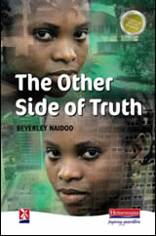

**The Other side of truth by Beverly Naidoo**

Tackles multiple themes, the right to freedom of speech, the complexities of political asylum, bullying, and ultimately the strength of the family.

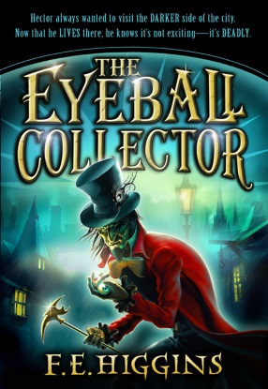

**The Eyeball Collector by FE Higgins**

A villain with a glass eyeball and an orphan seeking vengeance for his father’s death in a fantastical Victorian setting makes this riveting thriller a page turner. An intricate plot full of danger and menace will keep readers hooked. This is the third book in the darkly humorous Tales from the Sinister City series, but can be read as a stand-alone novel.

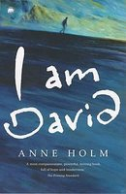

**I am David by Anne Holm**

The story of a young boy's journey through Europe after escaping from the camp where he had lived all his life. Sea, mountains and flowers, the colours of Italy, the taste of fruit, people laughing and smiling, all are new to David. This is also a voyage of self-discovery, as David learns that his polite manner, his haunted eyes and his thin features are strange to other people. A modern children’s classic.

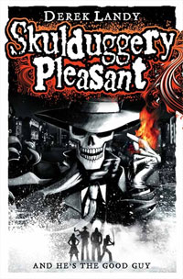

**Skulduggery Pleasant by Derek Landy**

Stephanie is joined in her pursuit of the truth behind her uncle’s mysterious death by a skeleton detective called Skulduggery who can do magic. A funny, magic, action-packed adventure story with a satisfying plot and great dialogue.

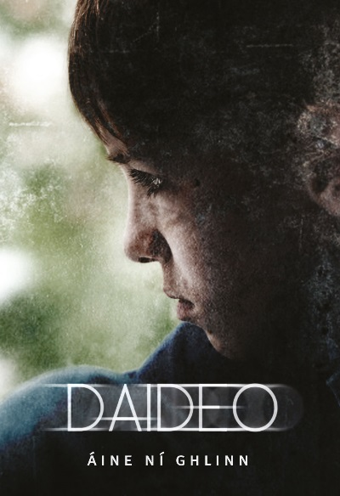

**Daideo by Aíne Ní Ghlinn**

Tá Liam ag éalú óna thuismitheoirí ar an traein go Baile Átha Cliath. Níl éinne eile leis agus tá sé ag folú ó fhear na dticéad. Buaileann sé le seanduine ar an traein agus ansin tosaíonn siad ag caint. Tá siad cosúil lena chéile, Liam agus an seanduine. Tá an seanduine ag éalú freisin ar an traein. An mbuaileann Liam le cara nua agus é ar a theitheadh?

Liam is escaping from his parents on the train to Dublin. There is no one else with him and he is hiding from the ticket man. He meets an old person on the train and they start talking. They are similar to each other, Liam and the old man. The old man is also escaping on thetrain. Has Liam met a new friend on his escape?

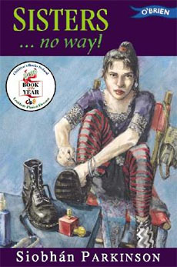

**Sisters..No Way? by Siobhán Parkinson**

Cindy is horrified when her father falls in love with a woman who has two teenage daughters of her own, but, like it or not, her father is getting remarried and she’ll have two new stepsisters. This is actually two great books in one, as the girls stories are told in two separate back-to-back books. The reader can choose which story to begin with getting a very different viewpoint from each one.

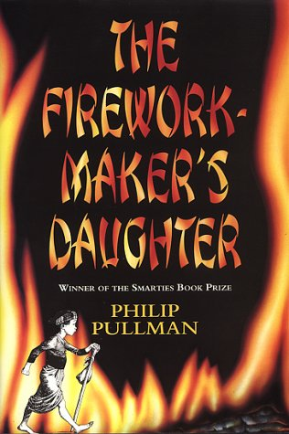

**The Firework Maker’s Daughter by Phillip Pullman**

Lila is the daughter of the firework maker and wishes to follow in his footsteps. Disobeying her father’s wishes, she embarks on a journey to learn the secrets of firework making in this imaginative fairytale. An exotic and bewitching read.

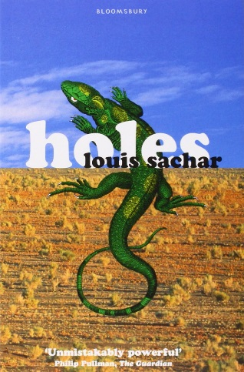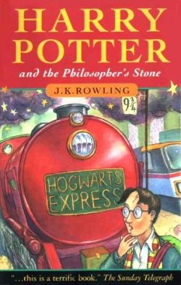

**Holes by Louis Sachar**

Stanley Yelnats is falsely accused of stealing a pair of sneakers and sent to Camp Green Lake for criminal boys and forced to dig holes for hours on end under the blazing desert sun. As the story moves between three different stories we begin to understand what has brought Stanley here, and what fate might have in store for him. A perceptive and complex novel, it explores bonds of family and friendship.

**Harry Potter and the Philosopher’s Stone by JK Rowling**

The orphaned Harry lives in the cupboard under the stairs in his awful aunt and uncle’s house. His dreary existence is changed forever when one day a mysterious letter arrives inviting him to Hogwarts School of Witchcraft and Wizardry. This is a magical, gripping story and the first in a wonderful series of novels. Any book from this series is a joy to read.

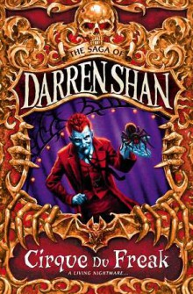

**Cirque du Freak by Darren Shan**

Darren is an average boy living an average life until a chance visit to a mysterious circus leads him into a thrilling and chilling adventure into a world of vampires and other fearsome monsters. A dark and witty read.



**Ice-Man: Tom Crean by Michael Smith**

This is the exciting, true story of Irish adventurer Tom Crean, who was part of three Polar expeditions 100 years ago. His amazing adventures in the world’s most hostile region will keep readers enthralled.

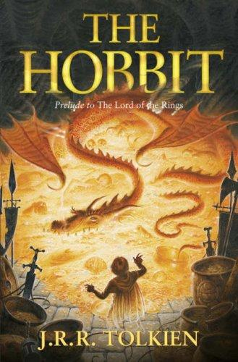

**The Hobbit by JRR Tolkien**

The classic bestseller behind this year’s biggest movie, this film tie-in edition features the complete story of Bilbo Baggins’ adventures in Middle-earth. Bilbo Baggins is a hobbit who enjoys a comfortable, unambitious life, rarely travelling further than the pantry of his hobbit-hole in Bag End. Until one day the wizard, Gandalf, and a company of thirteen dwarves arrive on his doorstep to whisk him away on an unexpected journey ‘there and back again’.

[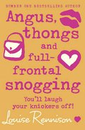](http://www.booktrust.org.uk/books/view/29396)

[**Angus, Thongs and Full-Frontal Snogging**](http://www.booktrust.org.uk/books/view/29396) **by Louise Rennison**

Welcome to the world of Georgia Nicolson - an angst-ridden teenage girl who keeps a diary to record the rollercoaster of emotions and experiences she faces every day.

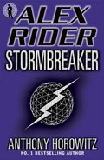

[**Stormbreaker**](http://www.booktrust.org.uk/books/view/30118) **by Anthony Horowitz**

Fourteen-year-old Alex Rider finds his life turned upside down on discovering that his late uncle wasn't a mild-mannered banker, but instead a field agent for MI6.

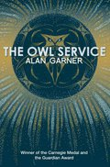

[**The Owl Service**](http://www.booktrust.org.uk/books/view/33347) **by Alan Garner**

Something is scratching around in the attic above Alison's room. Yet the only thing up there is a stack of grimy old plates. Alison and her stepbrother, Roger, discover that the flowery patterns on the plates, when traced onto paper, can be fitted together to create owls-owls that disappear when no one is watching. With each vanished owl, strange events begin to happen around Alison, Roger, and the caretaker's son, Gwyn. As the kids uncover the mystery of the owl service, they become trapped within a local legend, playing out roles in a tragic love story that has repeated itself for generations... a love story that has always ended in disaster.

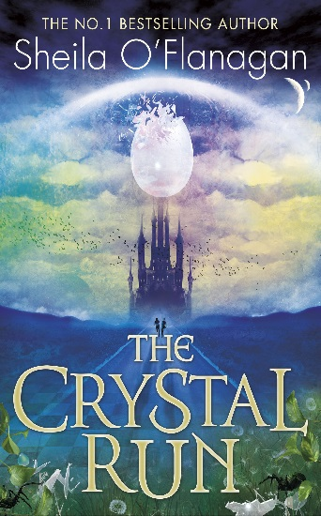

**The Crystal Run by Sheila O’Flanagan**

Frantic to escape from danger, Joe is transported to another world where he is plunged into the training regime of the Runners. Their mission is to protect the shield which keeps the Carcassians safe from their enemy, the Kanabians. Joe is instantly under suspicion: is he a terrorist, sorcerer or spy?  
When he is paired with Kaia of her Run, he realises how much is at stake. A Runner's destiny is death, but he can't let Kaia die.  
As they fight to escape, Joe needs to find a way to save them both. Well written with a strong plot and excellent characters, this book gives us an exciting fantasy filled with intrigue. This is the first in a series.

**2nd Year Book Recommendations**

[**Noughts and Crosses**](http://www.booktrust.org.uk/books/view/28476) **by Malorie Blackman**

Sephy is a Cross – a member of the dark-skinned ruling class. Callum is a Nought – a ‘colourless’ member of the underclass who were once slaves to the Crosses. The two have been friends since early childhood. But that’s as far as it can go. Against a background of prejudice and distrust a romance builds between Sephy and Callum – a romance that is to lead both of them into terrible danger…

[](http://www.booktrust.org.uk/books/view/28476)

**Knights of the Borrowed Dark by Dave Rudden**

Denizen Hardwick is an orphan, and his life is, well, normal. Orphans are just kids without parents. At least that’s what Denizen thought. On a particularly dark night, the gates of Crosscaper Orphanage open to a car that almost growls with power. The car and the man in it retrieve Denizen with the promise of introducing him to a long-lost aunt. But on the ride into the city, they are attacked. Denizen soon learns that monsters can grow out of the shadows. And there is an ancient order of knights who keep them at bay. Denizen has a unique connection to these knights, but everything they tell him feels like a half-truth. If Denizen joins the order, is he fulfilling his destiny, or turning his back on everything his family did to keep him alive?

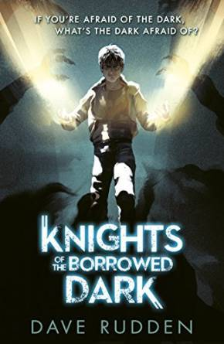

[](http://www.booktrust.org.uk/books/view/29230)

[**The Hunger Games**](http://www.booktrust.org.uk/books/view/29230) **Trilogy by Suzanne Collins**

Welcome to Panem: its Capitol repressively rules twelve satellite Districts, enslaving the populations as workers and controlling them through hunger. When 16-year-old Katniss's young sister, Prim, is selected as District 12's female representative in the annual Reaping which sees people fight to the death, Katniss volunteers to take her place. She and her male counterpart Peeta, are pitted against bigger, stronger representatives, some of whom have trained for this their whole lives. , she sees it as a death sentence. But Katniss has been close to death before. For her, survival is second nature.

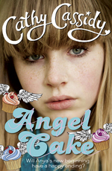

**Angel Cake by Cathy Cassidy**

Anya had been looking forward to moving from Poland to England but finds life more difficult than she had expected when she starts at her new school in Liverpool. She is bullied and lonely at school but things begin to look up when she makes friends (and falls in love) with bad boy Dan. This is a sweet and funny look at teenage issues and friendships.



**The Diamond of Drury Lane by Julia Golding**

Set in 1790's Covent Garden, this book whisks you back to a bygone era and into the magic of the theatre. Cat Royal's colourful slang and confident I'll-tell-you how-it-really-is attitude makes the story sparkle off the page. She is an orphan who lives at the back of the Theatre Royal in Drury Lane, and mingles with the high and low of society. Packed with authentic detail, it’s also a gripping mystery.

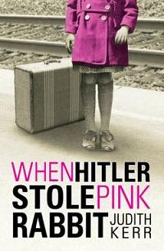

**When Hitler Stole Pink Rabbit by Judith Kerr**

A lovely, touching book, often very funny, about a girl called Anna, whose family must flee Nazi Germany for Switzerland during World War 2

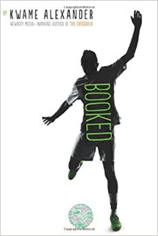

**Booked by Kwame Alexander**

Nick Hall is star of the football team. It seems that his crush, April, likes him too. His world is pretty perfect, until a shocking announcement turns it upside down. Suddenly his life, on and off the pitch, becomes more complicated. This novel is full of energy and emotion and explores family, friendships and growing up, as well as football.

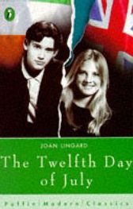

**The Twelfth Day of July by Joan Lingard**

First published in 1970 and set in a Belfast divided along sectarian lines, this powerful novel is about the tension and danger that surround the growing friendship of Protestant Sadie and Catholic Kevin.

**Carbon Diaries 2015 by Saci Lloyd**

It’s 2015 and the UK is the first country to introduce carbon rationing in a drastic bid to combat climate change. Seventeen year old Laura chronicles the changes in her family and the world around her in short diary entries. This riveting ecothriller is compelling reading with unexpectedly light hearted moments.

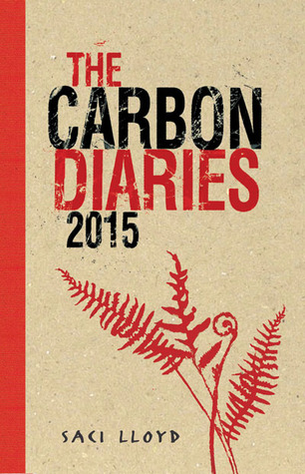



**And Actually… by Denise Deegan**

This is the third volume in the Butterfly Novels series, about 3 friends, Alex, Sarah and Rachel who attend an elite Dublin school for children of the rich and famous. This one focuses on the ‘together’ Rachel, the problem-solver of the group – who turns out to have a problem of her own. Haunted by bullying she experienced in primary school, Rachel is forced to confront her past when she finds herself working with one of her tormentors on the set of an Irish medical drama. Combines serious issues with the glamorous world of television.

**Apple and Rain by Sarah Crossan**

When Apple's mother returns after eleven years of absence, Apple feels whole again. She will have an answer to her burning question – why did you go? And she will have someone who understands what it means to be a teenager – unlike Nana. But just like the stormy Christmas Eve when she left, her mother's homecoming is bittersweet, and Apple wonders who is really looking after whom. It's only when Apple meets someone more lost than she is, that she begins to see things as they really are.

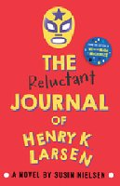

**The Reluctant Journal of Henry K. Larson by Susin Nielsen**

Henry’s keeping a diary under duress; his therapist thinks it will help him deal with his brother’s death. But even in a new town, as he befriends a handful of vivid and relatable outsiders, fresh starts prove to be trickier than they seem. With humour balancing out the seriousness of the topic, this is an immensely readable story about a family recovering from a shooting and a teenage boy to come to terms with his own sense of guilt.



**Apple Tart of Hope by Sarah Moore Fitzgerald**

The best baker in the world, Oscar Dunleavy, is missing. Everyone presumes he is dead but no one seems too surprised. Only Meg, his best friend, and his little brother Stevie are shocked. Surrounded by grief and confusion, Meg and Stevie are determined to find out what happened to Oscar, and together they learn about loyalty and friendship and the power of never giving up hope.

**The Diary of a Young Girl by Anne Frank**

In the summer of 1942, fleeing the horrors of the Nazi occupation, Anne Frank and her family were forced into hiding in the back of an Amsterdam warehouse. Aged thirteen when she went into the secret annexe, Anne kept a diary in which she confided her innermost thoughts and feelings. An intimate record of tension and struggle, adolescence and confinement, anger and heartbreak, this is the definitive edition of the diary of Anne Frank.

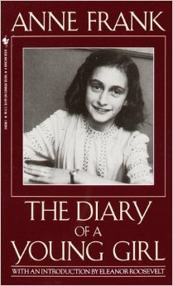

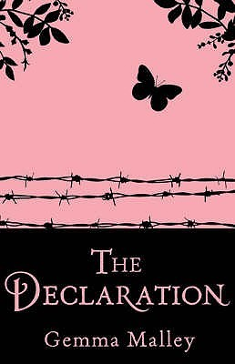

**Chalkline by Jane Mitchell**

Rafiq is only nine but he’s tall for his age and when Kashmiri freedom fighters come to his village looking for new recruits he is forced to go with them. This hard hitting look at terrorism is a page turner.

**The Declaration by Gemma Malley**

In the overpopulated future of 2140 fourteen year old Anna has grown up in a detention centre for illegally conceived children. She is Surplus but is training hard to become a Valuable Asset. A chilling dystopian novel set in a future where the existence of longevity drugs means that people can live forever.



**The Other side of truth by Beverly Naidoo**

Tackles multiple themes, the right to freedom of speech, the complexities of political asylum, bullying, and ultimately the strength of the family.

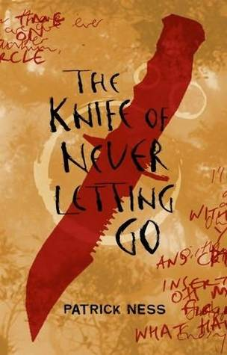

**The Knife of never letting go (Chaos Walking 1) by Patrick Ness**

Todd is forced to face some impossible choices in this astounding suspense filled novel with a western/sci-fi vibe. In Prentisstown everyone can hear everyone else’s thoughts, all the women are gone and Todd is the only boy left. The first in the “Chaos Walking” trilogy.

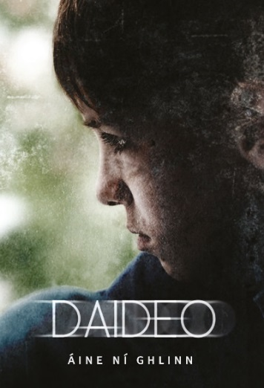

**Daideo by Aíne Ní Ghlinn**

Tá Liam ag éalú óna thuismitheoirí ar an traein go Baile Átha Cliath. Níl éinne eile leis agus tá sé ag folú ó fhear na dticéad. Buaileann sé le seanduine ar an traein agus ansin tosaíonn siad ag caint. Tá siad cosúil lena chéile, Liam agus an seanduine. Tá an seanduine ag éalú freisin ar an traein. An mbuaileann Liam le cara nua agus é ar a theitheadh? Liam is escaping from his parents on the train to Dublin. There is no one else with him and he is hiding from the ticket man. He meets an old person on the train and they start talking. They are similar to each other, Liam and the old man. The old man is also escaping on thetrain. Has Liam met a new friend on his escape?

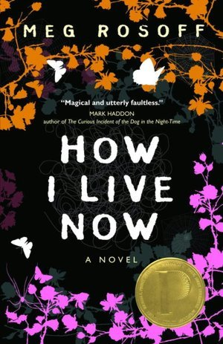

**How I live now by Meg Rosoff**

15 year-old Daisy thinks she knows all about love. Her mother died giving birth to her, and now her dad has sent her away for the summer to live in the English countryside with cousins she’s never met. There her world will be turned upside down and a perfect summer will explode into a million bewildering pieces. How will Daisy live then?

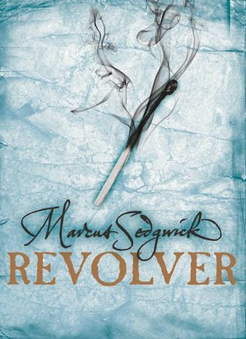

**Revolver by Markus Sedgwick**

A tense psychological drama set in 1910 in the Antarctic Wilderness where a boy must confront a stranger come to take revenge on his dead father. A haunting, beautifully written, fast paced tale of survival.



**The Hobbit by JRR Tolkien**

The classic bestseller behind this year’s biggest movie, this film tie-in edition features the complete story of Bilbo Baggins’ adventures in Middle-earth. Bilbo Baggins is a hobbit who enjoys a comfortable, unambitious life, rarely travelling further than the pantry of his hobbit-hole in Bag End. Until one day the wizard, Gandalf, and a company of thirteen dwarves arrive on his doorstep to whisk him away on an unexpected journey ‘there and back again’.

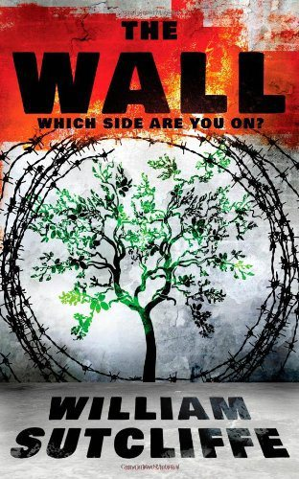

**The Wall by William Sutcliffe**

Joshua is thirteen. He lives with his mother and stepfather in Amarias, an isolated town on top of a hill, where all the houses are brand new. At the edge of Amarias is a high wall, guarded by soldiers, which can only be crossed through a heavily fortified checkpoint. Joshua has been taught that beyond the concrete is a brutal and unforgiving enemy, and that The Wall is the only thing keeping him and his people safe. One day, looking for a lost football, Joshua stumbles across a tunnel which leads towards this forbidden territory. The Wall is a novel about a boy who undertakes a short journey to another world, to a place where everything he knows about loyalty, identity and justice is turned upside down. It is also a political fable that powerfully evokes the realities of life on the West Bank, telling the story of a Settler child who finds there are two sides to every story.

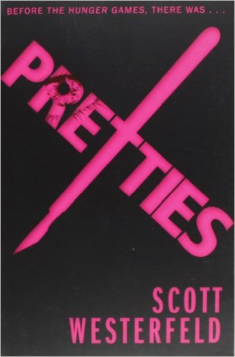

**Pretties by Scott Westerfield**

In the second volume of the Uglies quartet, Tally has finally become Pretty. Now her looks are beyond perfect, her clothes are cool, her boyfriend is totally gorgeous, and she's completely popular. But beneath all the fun - the non-stop parties, the high-tech luxury, the total freedom - is the nagging sense that something is very wrong. Then a message from Tally's Ugly past arrives. Reading it, Tally remembers what's wrong with Pretty life. Now she has to choose between fighting to forget what she knows and fighting for her life...

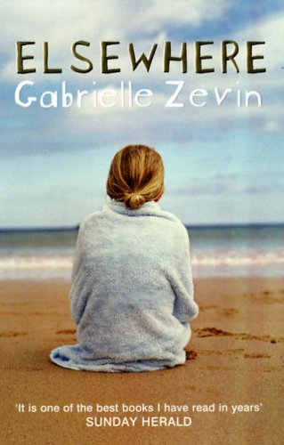

**Elsewhere by Gabrielle Zevin**

Fifteen year old Liz has died and ended up in a place called Elsewhere. Here she will age backwards until she is reborn again on Earth. This is a moving and funny look at the possibilities offered by an afterlife

[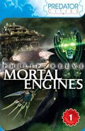](http://www.booktrust.org.uk/books/view/24773)

**Mortal Engines by Philip Reeve**

London is on the move again: the traction city trawls the world on wheels, capturing and eating smaller towns.

[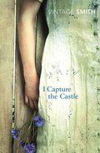](http://www.booktrust.org.uk/books/view/24572)

[**I Capture the Castle**](http://www.booktrust.org.uk/books/view/24572) **by Dodie Smith**

17-year-old Cassandra lives an eccentric existence with her bohemian family in a crumbling castle in the English countryside, in this delightful classic coming-of-age story.

[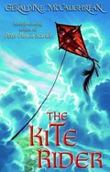](http://www.booktrust.org.uk/books/view/30036)

[**The Kite Rider**](http://www.booktrust.org.uk/books/view/30036) **by Geraldine McCaughrean**

Haoyou feels powerless when the man responsible for his father's death demands to marry his mother. Determined to support her himself, the young boy joins a travelling circus.

[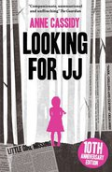](http://www.booktrust.org.uk/books/view/24551)

[**Looking for JJ**](http://www.booktrust.org.uk/books/view/24551) **by Anne Cassidy**

When a 10-year-old girl kills her best friend, she is convicted of manslaughter and locked away. Seven years later she is released on licence with a new identity.

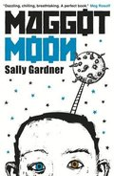

[**Maggot Moon**](http://www.booktrust.org.uk/books/view/32456) **by Sally Gardner**

Combining conspiracy theory and dystopia, this hugely original novel is set in an alternate 1950s in which Britain is dominated by the ruthlessly oppressive forces of The Motherland.

**3rd Year Book Recommendations**

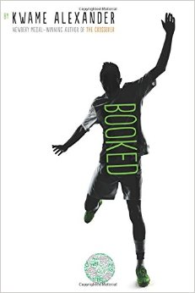

**Booked by Kwame Alexander**

Nick Hall is star of the football team. It seems that his crush, April, likes him too. His world is pretty perfect, until a shocking announcement turns it upside down. Suddenly his life, on and off the pitch, becomes more complicated. This novel is full of energy and emotion and explores family, friendships and growing up, as well as football.

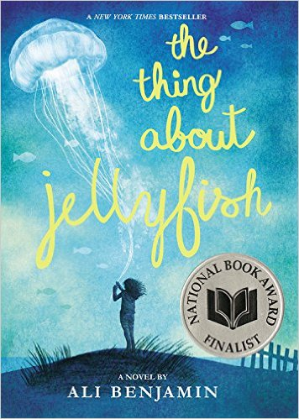

**The Thing about Jellyfish by Ali Benjamin**

Ever since her best friend drowned on holiday, Suzy has stopped speaking. None of it makes sense. She was a confident swimmer, so Suzy is convinced there must be more to the story. Her conclusion? Jellyfish. Suzy is on a mission to prove that these ethereal creatures were responsible. The story is laid out in a perfect science-report format, which suits the voice and interest of the main character. A touching account of broken friendships, grief, resilience, and coping with loss.

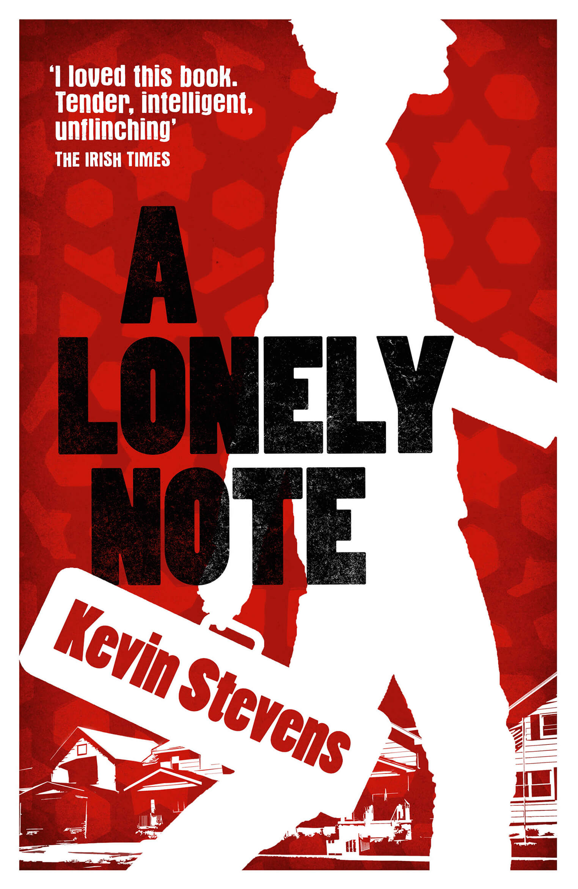

**A Lonely Note by Kevin Stevens**

This story recounts the tale of Tariq, an Iraqi teen growing up in a Wisconsin town. Throughout the novel, Tariq faces a number of challenges related to religious acceptance and the navigation between American culture and traditional Islam. His passive approach to solving challenges makes for frustrating protagonist; in the end, however, he grows up more than anticipated. A compelling read about tolerance, family and bullying that is sure to keep teens turning the page..

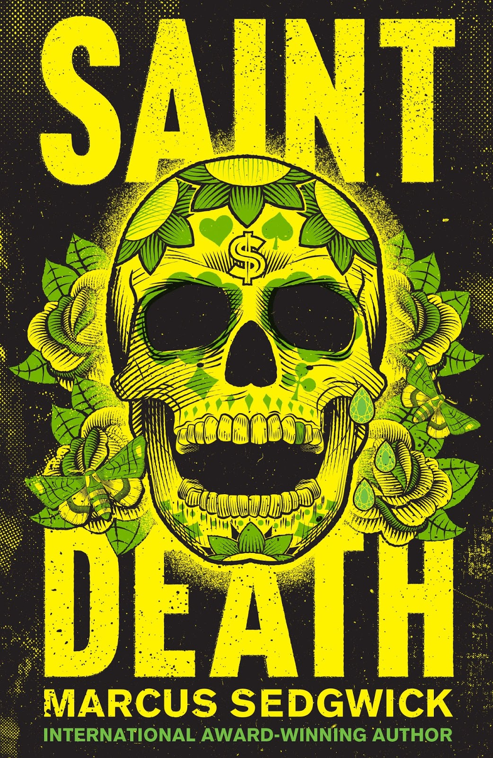

**Saint Death by Marcus Sedwick**

A dark and powerful tale, set on the Mexican/US border, about violent gangs, drug trafficking and poverty. Another gem from this prize winning author, whose masterful delivery of prose will leave you breathless. Arturo is a stunningly written character, while life is all about survival and not drawing attention to himself. When his friend dips into money that is not his to spend, they have thirty-six hours to replace it. A quick paced and addictive read for young adult readers and up.

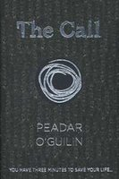

**The Call by Peadar O Guilin**

The Sidhe are a race that have been banished from Ireland and now live in the Greylands. They are angry and decide to take revenge on the teenagers of Ireland. Three minutes is all the teenagers have to survive the hunt of the Call. They hear a horn and they know that whoever lives in this hell has got their scent and the hunt has already begun. Nessa is struggling to protect herself from the Sidhe, as she has polio and is weaker than most fourteen year olds. A thrilling fantasy tale full of excitement and unpredictable twists, gripping and engrossing from the start.



**The Reluctant Journal of Henry K. Larson by Susin Nielsen**

Henry’s keeping a diary under duress; his therapist thinks it will help him deal with his brother’s death. But even in a new town, as he befriends a handful of vivid and relatable outsiders, fresh starts prove to be trickier than they seem. With humour balancing out the seriousness of the topic, this is an immensely readable story about a family recovering from a shooting and a teenage boy to come to terms with his own sense of guilt.

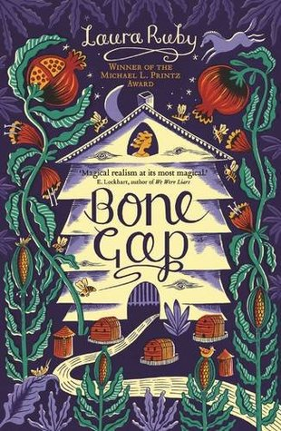

**Bone Gap by Laura Ruby**

Bone Gap is a town with gaps, spaces you can slip through. No one is too surprised when beautiful young Roza disappears. Finn is the only one who saw her kidnapper, but he can't describe her face. He knows Roza was taken, even if everyone else believes she chose to leave. Weaving together the stories of different people from the town, this is a skilfully written piece of magical realism. It is a book about love and what it means to see an be seen.

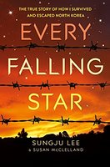

**Every Falling Star by Sungju Lee and Susan McClelland**

A hard hitting memoir of a North Korean boy named Sunju Lee. Containing gripping details of the hardships he had to endure, and the tragedies he faced, this book is sure to hold the attention of any reader. Sunju transports the reader to his past and shows them his own path of hope.

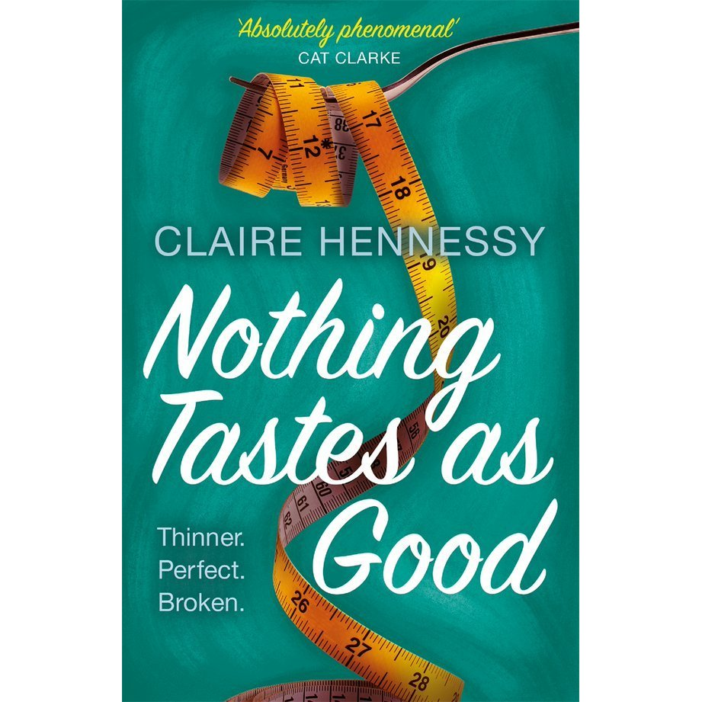

**Nothing Tastes as Good by Claire Hennessy**

Don't call her a guardian angel. Annabel is dead- but she hasn't completely gone away. The central concerns of self confidence and happiness are examined through an exposition of Annabel’s anorexia, the disease that claimed her life just shy of her eighteenth birthday. She tries to help ex classmate Julia, who gradually lets Annabel’s voice in, guiding her thoughts towards her body, food and control. But nothing is as simple as it first seems. A memorable story about the pressures felt by young women to fit a certain mould, written by a master storyteller.

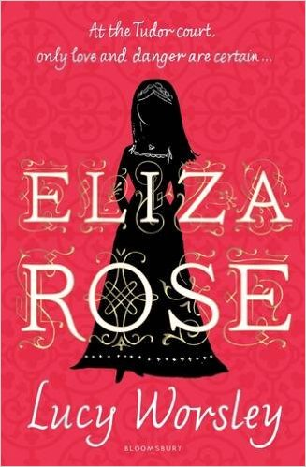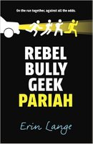

**Eliza Rose by Lucy Worsley**

Eliza is a head strong heroine of this sparkling debut novel. The book gives us a glimpse behind the scenes of the often cruel realities for young women at the court of Henry VIII. The story telling is smart and funny, and while initially Eliza is keen to experience court life and has romantic ideas about finding love and marriage, she is also on the receiving end of some catty behaviour from her ambitious cousin Katherine Howard.

**Rebel, Bully, Geek, Pariah by Erin Lange**

Sam’s used to hiding her personality and scars under her grubby hat, but when she finds herself fleeing an accident in a stolen police car along with three of her classmates she's forced to reveal her true self. Some of the characters early decisions stretch believability, but once they're on the road the story takes off, jumping from adventure to adventure and twisting its way to a fantastic ending. A fast paced thriller that also explores the ways that relationships both damage and sustain us.

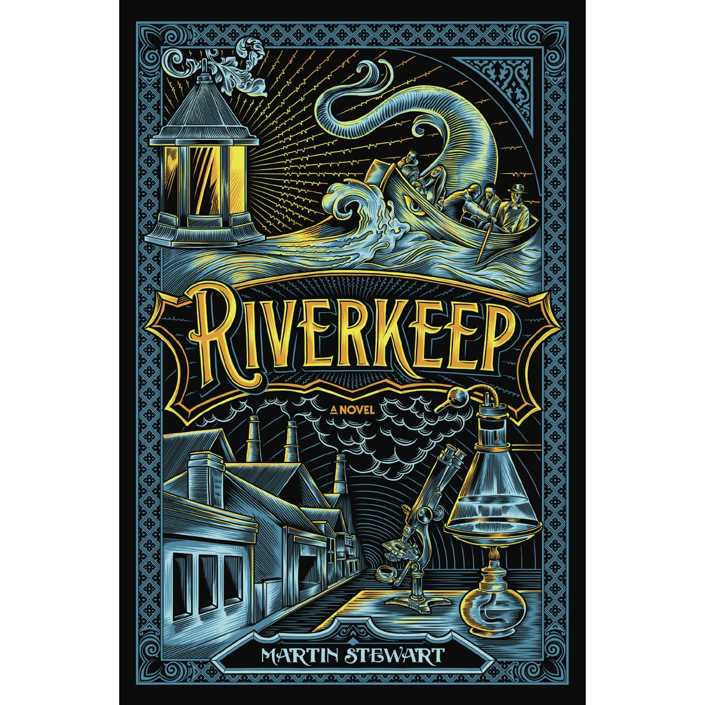

**Riverkeep by Martin Stewart**

Wull is getting ready to covers his father’s job as Riverkeep, pulling corpses from the River Danek. But when his father becomes possessed by something from the river, Wull has to both Riverkeep and find a cure for his father before it’s too late. The language in this book is amazing to read, and the story is both arresting and evocative. This book is definitely a keeper, a fascinating read.

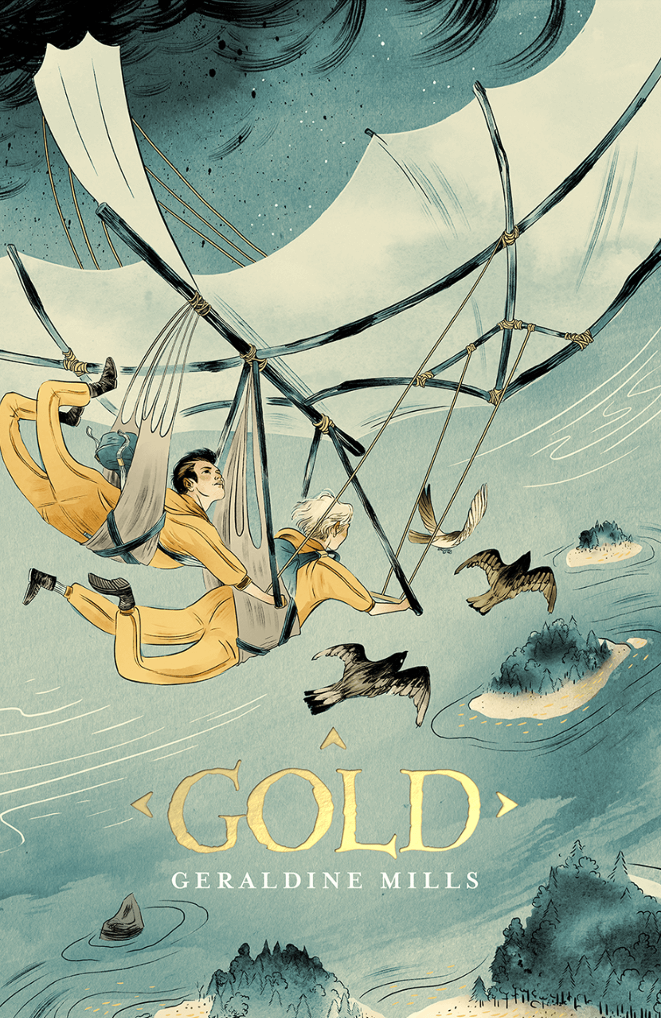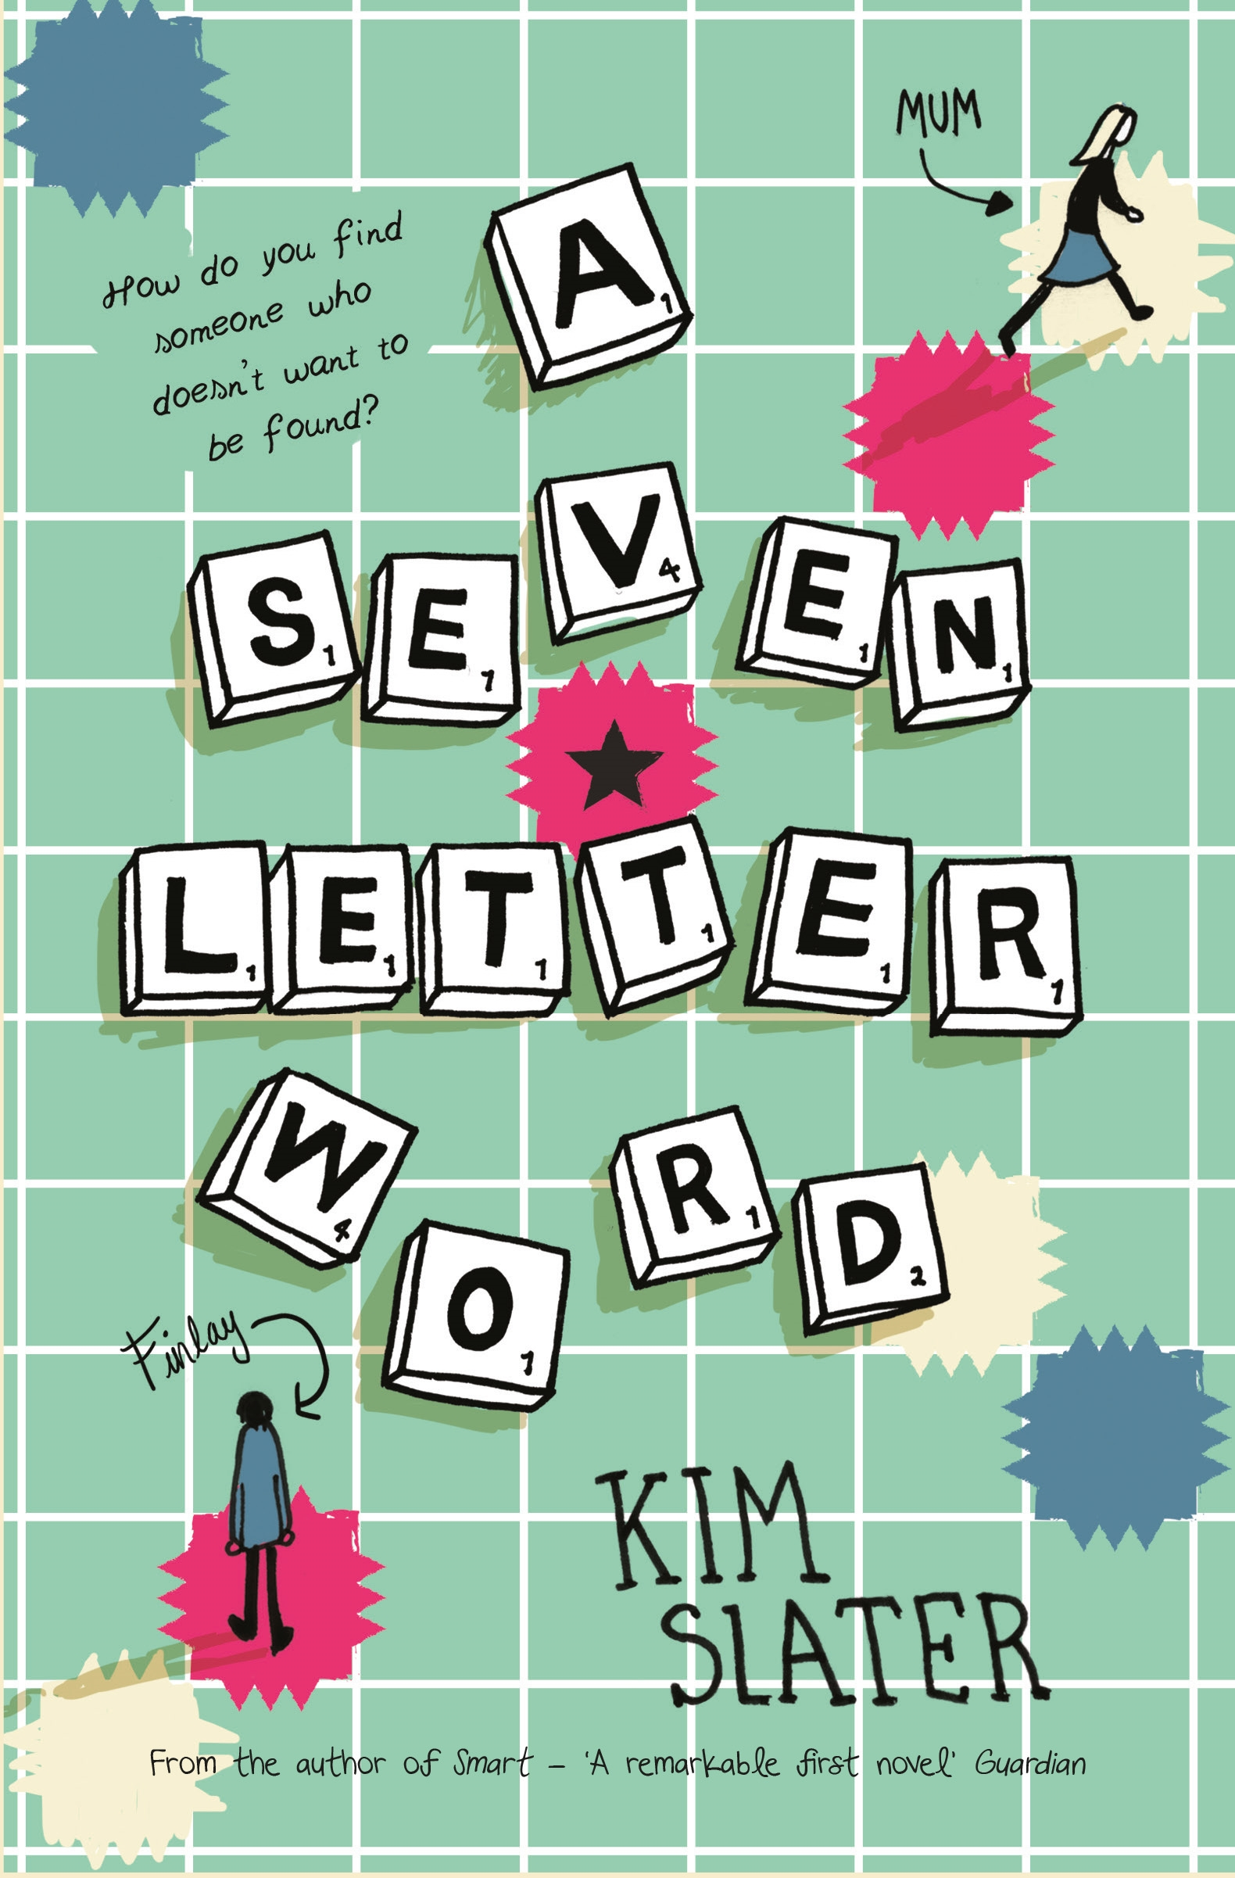

**A Seven-Letter Word by Kim Slater**

Scrabble is cleverly woven into both the form and content of this novel about a teenagers search for the mother who abandoned him. Finlay’s stutter renders him unable to speak and open to bullying, but he uses his Scrabble prowess as an alternative means of expression. Initially, this may seem a predictable tale about overcoming adversity, but it develops into an intriguing mystery as Finlay investigates his mother’s disappearance.

**Gold by Geraldine Mills**

Starn and Esper are twin brothers who live with their father in a dark world polluted by ash. Food is scarce, everything is controlled. Their father tells them stories of his old life on the islands before the ash, before their mother and sister died. When the boys find a treasure map they come up with an audacious plan to build a glider, travel to the islands and find the gold they believe is hidden there. An action packed adventure with a stark environmental message.

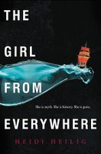

**The Girl from Everywhere by Heidi Heilig**

Nix Song is a Time Traveller, like her dad. Her special ability lets her use maps to travel not just around the world, but also through time itself. But what is her father’s obsession with 1868, and what will it mean for Nix if he succeeds in getting back to that time? This beautifully written story full of love, magic, mystery and heartbreak will captivate the heart and mind of any reader.

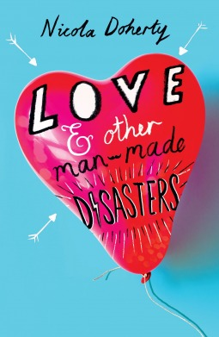

**Love and Other Man-Made Disasters by Nicola Doherty**

Juno is scared of everything, from her upcoming exams to natural disasters. A ski trip with her new stepfamily is both the last thing she wants and exactly what she needs. This is a warm and realistic story about a girl taking chances, making friends, falling in love and finding her path in the world.

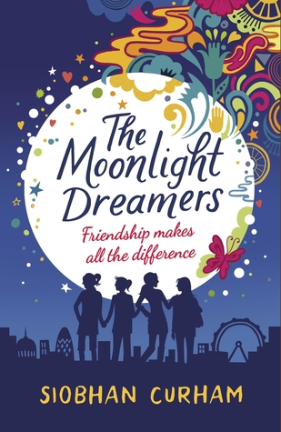

**The Moonlight Dreamers by Siobhan Curham**

Amber is sick of being bullied at school, so she decides to set up The Moonlight Dreamers. Her secret society, inspired by an Oscar Wilde quote, is for girls who don’t quite fit in, girls who dare to dream. Amber, Maali, Sky and Rose have different personalities and different challenges to face but together they find the courage to believe in themselves and their goals. A heart-warming read about the transformative power of friendship and the value of going your own way.

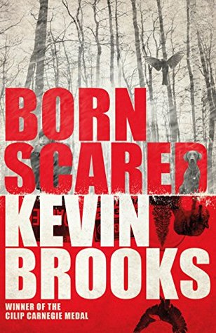

**Born Scared by Kevin Brooks**

Elliot is terrified of almost everything. From the moment he was born, his life has been governed by acute fear. The only thing that keeps his terrors in check are the pills that he takes every day.  
It's Christmas Eve, there's a snowstorm and Elliot's medication is almost gone. His mum nips out to collect his prescription. She'll only be 10 minutes - but shen she doesn't come back, Elliot must face his fears and try to find her. She should only be 400 metres away. It might as well be 400 miles. A suspense ride that builds tension throughout, this will stay with you long after you turn the final page.

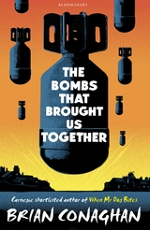

**The Bombs that Brought us Together by Brian Conaghan**

Fourteen-year-old Hamish Law has lived in Little Town, on the border with Old Country, all his life. He knows the rules: no going out after dark; no drinking; no litter; no fighting. You don't want to get on the wrong side of the people who run Little Town. When he meets Pavel Duda, a refugee from Old Country, the rules start to get broken. Then the bombs come, and the soldiers from Old Country, and Little Town changes for ever. Sometimes, to keep the people you love safe, you have to do bad things. As Little Town's rules crumble, Hamish is sucked into a dangerous game.

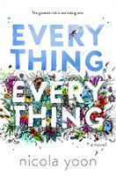

**Everything, Everything by Nicola Yoon**

My disease is as rare as it is famous. Basically, I’m allergic to the world. I don’t leave my house, have not left my house in seventeen years. The only people I ever see are my mom and my nurse, Carla. But then one day, a moving truck arrives next door. I look out my window, and I see him. He’s tall, lean and wearing all black—black T-shirt, black jeans, black sneakers, and a black knit cap that covers his hair completely. He catches me looking and stares at me. I stare right back. His name is Olly. Maybe we can’t predict the future, but we can predict some things. For example, I am certainly going to fall in love with Olly. It’s almost certainly going to be a disaster.

**Spare and Found Parts by Sarah Maria Griffin**

This novel presents a post-apocalyptic Dublin as the backdrop where our protagonist Nell Crane has always been an outsider. In a city devastated by an epidemic, where survivors are all missing parts—an arm, a leg, an eye—her father is the famed scientist who created the biomechanical limbs everyone now uses. But Nell is the only one whose mechanical piece is on the inside: her heart. Since the childhood operation, she has ticked. Like a clock, like a bomb. Then she finds a mannequin hand while salvaging on the beach—the first boy’s hand she’s ever held—and inspiration strikes. Can Nell build her own companion in a world that fears advanced technology? The deeper she sinks into this plan, the more she learns about her city—and her father, who is hiding secret experiments of his own.

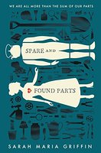

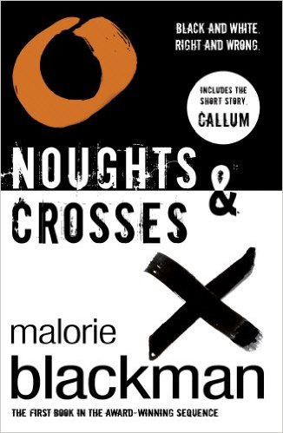

[**Noughts and Crosses**](http://www.booktrust.org.uk/books/view/28476)**by Malorie Blackman**

Sephy is a Cross – a member of the dark-skinned ruling class. Callum is a Nought – a ‘colourless’ member of the underclass who were once slaves to the Crosses. The two have been friends since early childhood. But that’s as far as it can go. Against a background of prejudice and distrust a romance builds between Sephy and Callum – a romance that is to lead both of them into terrible danger…

**The Lie Tree by Francis Hardinge**

To an outside observer, fearless Victorian heroine Faith may seem boring, but beneath her dull exterior lies a mind bursting with curiosity, intelligence, and passion. When her scientist father moves their family from London to a clannish island following a scandal, Faith is desperate to get to the bottom of things…especially once he turns up dead. Certain he was murdered, Faith ransacks his possessions, and discovers a tree that bears fruit only upon hearing lies. The plot thickens as Faith uses the tree to spread falsehoods throughout the town in a desperate quest for the truth, wielding others’ perceptions of her against them. Winner of the Costa Book of the Year 2015.

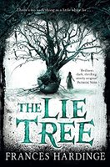

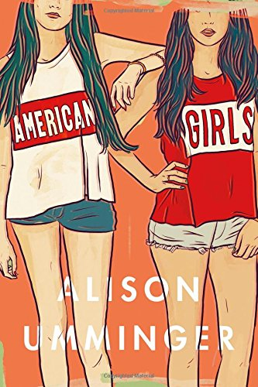

[**American Girls**](http://www.barnesandnoble.com/w/american-girls-alison-umminger/1122677512?ean=9781250075000)**, by Alison Umminger**

Fleeing a childish mother, a stalled life, and a guilty conscience, 15-year-old Anna runs away to Los Angeles to live with her D-list actress sister. She spends her days chasing down donuts, trailing her sister around town, and hanging out on the set of the universally despised kids’ show where her sister’s boyfriend is a writer. Her outsider’s view of Hollywood’s has-beens and never-weres winds together with her background research on the Manson girls, at the behest of her sister’s creepy director ex. Like Manson’s followers, Anna is hungry, lost, and stuck on the fringes, watching her sister’s life crash while she avoids the wreckage of her own. And her voice is perfect: forthright and earthy, equal parts wistful beauty and teen harshness.