Hi all

Hope you are all well.

Remember - Careers Drop in Clinic (quick questions)
Mondays - Office across from F32 Stephanie
Thursdays - Eva C's Office S09

DARE Reminder: Thanks to those who have completed already.

As the CAO is open, so too is DARE (Disability Access Route to Education). If you are eligible for DARE you must
- Create an account with the CAO before the 1st February
- Indicate on your CAO that you are applying for DARE
- Complete section A on your CAO by the 1st March (can use bullet points)
- Post Section B and C (and D if necessary) to the CAO by the 15th March

As the school need to complete section B as part of your application, we require you to complete the below form so that we know you are applying for DARE and can work with you to complete it. Please complete the brief Microsoft form below by December 1st.

https://forms.office.com/Pages/ResponsePage.aspx?id=9cjWPhZMrUSe7WD4UYNKhGNu1AVgU25JpLdRX0rpsDlURjVGQkkwUUk3VjdVWUNINVRYT004STJRRC4u

Some updates for this week:

- Some new CAO courses -
New CAO Courses - Careers and Education News (careersnews.ie)

2. Hpat 2024 - Registration Open
Health Professions Admission Test - HPAT Ireland (acer.org)
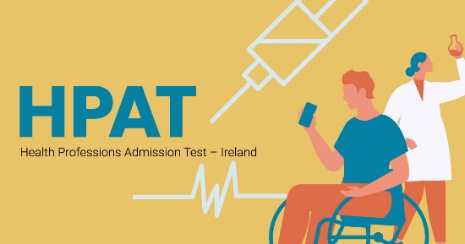 | Health Professions Admission Test  HPAT is a 2.5-hour online multiple-choice assessment, assessing skills for academic success in medical and allied health courses.  hpat-ireland.acer.org

3. Free Webinars - next - Careers in Accounting and Finance and Why study Arts?

Webinars & Workshops - Synergy Careers

4. Reminder:
Maynooth Open days - this Friday and Saturday
IADT - Saturday 25th

- UCD - various Open evenings - see attached
Events - UCD Undergraduate Courses (myucd.ie)

6. RCSI - study Pharmacy/Medicine webinar

Live webinars and international events - Royal College of Surgeons in Ireland (rcsi.com)

Live webinars and international events - Royal College of Surgeons in Ireland (rcsi.com)

7. TUD - Grangegorman Open Day - 2nd December

Open Day 2023 | TU Dublin

